“A HEALTHY EATING PLATE”
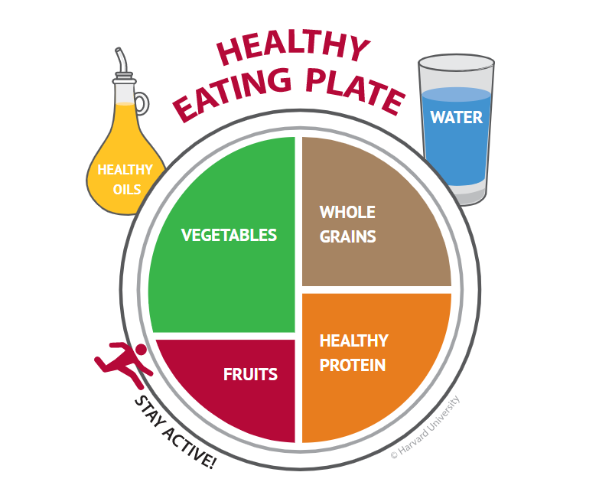
A healthy eating plate is a visual representation of a balanced and nutritious meal, designed to guide individuals towards making healthier food choices. The plate is divided into four sections, representing the recommended proportions of food groups that should make up a healthy diet.

The largest section of the plate, occupying about half of the space, is dedicated to fruits and vegetables. This is because these food groups are low in calories and high in fiber, vitamins, and minerals, making them essential for maintaining overall health and reducing the risk of chronic diseases such as heart disease, cancer, and diabetes.

The remaining half of the plate is divided into three equal sections. One section is dedicated to whole grains, which provide the body with essential carbohydrates, fiber, and B-vitamins. Whole grains include foods such as brown rice, quinoa, oats, and whole wheat bread.

The second section is dedicated to lean proteins, such as fish, poultry, tofu, beans, and lentils. These foods provide essential amino acids, which are the building blocks of protein, and are necessary for building and repairing tissues in the body.

The final section of the plate is reserved for healthy fats, such as those found in nuts, seeds, avocado, and olive oil. These foods are important for providing the body with essential fatty acids, which play a crucial role in brain function, cell growth, and hormone production.

In addition to the four main sections of the healthy eating plate, it is also important to consider the types of beverages consumed. Water is the best option for staying hydrated, and individuals should aim to drink at least 8 cups per day. Sugary beverages such as soda and sports drinks should be avoided or limited, as they can contribute to weight gain and increase the risk of chronic diseases.

When planning meals, it is important to aim for a variety of foods within each section of the healthy eating plate. This ensures that the body receives all of the essential nutrients it needs for optimal health. It is also important to pay attention to portion sizes, as overeating can lead to weight gain and other health problems.

Overall, following the recommendations of the healthy eating plate can lead to a balanced and nutritious diet, which can help individuals maintain optimal health and reduce the risk of chronic diseases.
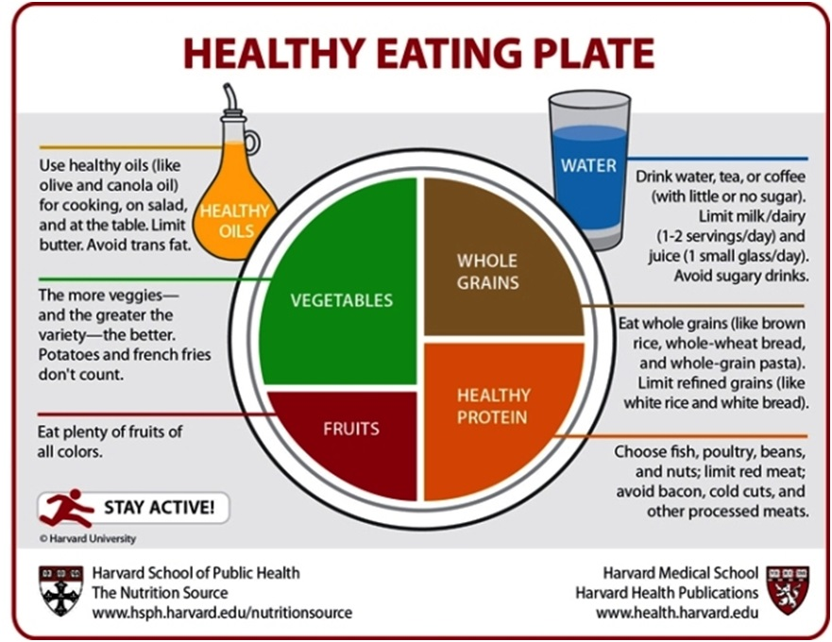

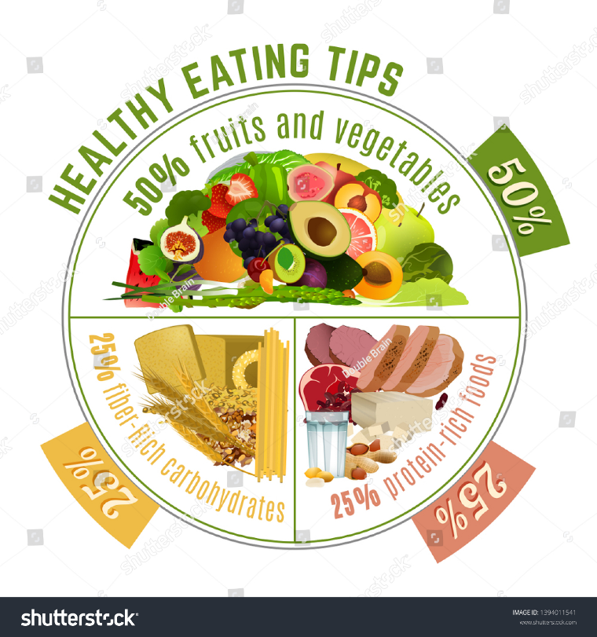
“TIPS FOR HEALTHY EATING”

